Github repo: https://github.com/azmat-s/hospital-management-System

After narrowing down, we updated the objective (see GitHub) and focused on:

Hospital Clinical Orders & Billing Database Design Document

1. Business Problems Being Addressed
Modern hospitals face increasing complexity in linking clinical operations (prescriptions, lab tests, procedures) with financial workflows (billing, insurance claims, and payments).
Many existing systems either:
- Lack integration between clinical and billing modules
- Cannot easily track the financial impact of each medical order
- Require manual reconciliation between clinical orders and insurance claims
This database aims to solve these issues by integrating Clinical Orders and Billing/Insurance processes within a unified relational structure.
It supports:
- Tracking all orders (medication, lab tests, procedures) per encounter
- Automatically generating billing charges based on orders
- Managing insurance policies and claims linked to patients
- Recording payments and monitoring outstanding balances
- Enabling reporting on order utilization, revenue, and claim performance
2. ERD
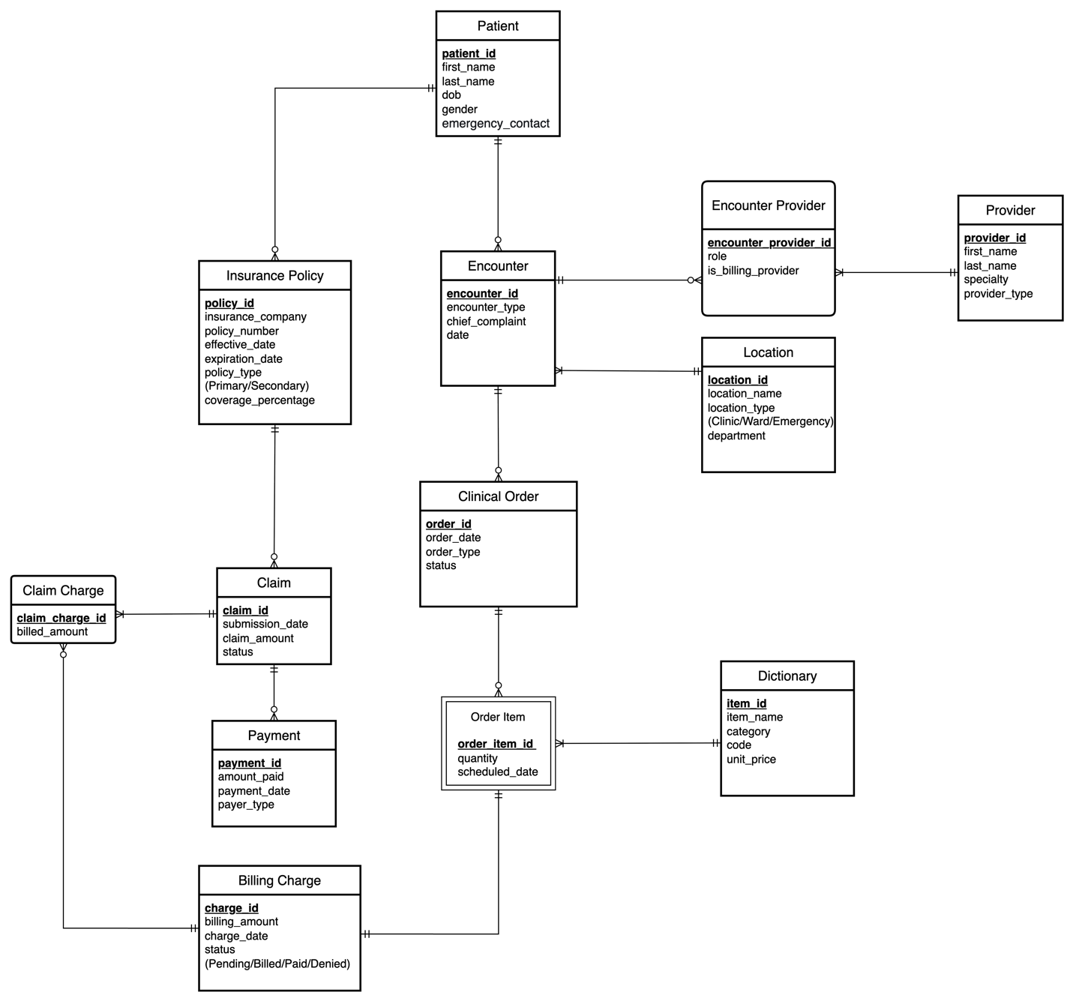

3. Entities, Key Attributes, and Descriptions
Entity | Key Attributes | Description / Role
Patient | patient_id (PK), first_name, last_name, dob, gender, emergency_contact | Stores demographic and contact information for each patient.
Encounter | encounter_id (PK), patient_id (FK), encounter_date, encounter_type, location_id, chief_complaint | Represents a single visit, admission, or treatment event for a patient.
Provider | provider_id (PK), name, specialty, provider_type | Holds details for clinicians who issue or fulfill clinical orders.
Encounter_Provider | encounter_id (FK), provider_id (FK), role, is_billing_provider | Resolves the many-to-many relationship between encounters and providers (e.g., primary vs. consulting doctor).
Location | location_id (PK), name, type, department | Represents the physical or organizational unit where an encounter or order occurs.
Clinical_Order | order_id (PK), encounter_id (FK), order_date, status, order_type | Captures each set of medical orders made during an encounter (e.g., lab test, medication, imaging).
Order_Item | order_item_id (PK), order_id (FK), dictionary_id (FK), quantity, scheduled_date | Stores specific order details; links to standard procedure/test codes.
Dictionary | dictionary_id (PK), code, description, category, unit_price | Serves as a standardized catalog for all billable items—lab tests, drugs, or procedures.
Billing_Charge | billing_id (PK), order_item_id (FK), amount, status, charge_date | Represents the financial record created from each order item for billing purposes.
Insurance_Policy | policy_id (PK), patient_id (FK), insurer_company, policy_number, coverage_percent, expiry_date, effective_date, policy_type | Defines a patient’s insurance coverage.
Claim | claim_id (PK), policy_id (FK), submission_date, status, claim_amount | Represents an insurance claim submitted for one or more charges.
Claim_Charge | claim_charge_id (PK), claim_id (FK), billing_id (FK), approved_amount, payment_status | Breaks down each claim into individual billed items.
Payment | payment_id (PK), claim_id (FK), amount_paid, payment_date, payer_type | Records actual payments received from insurer or patient.

4. Relationships Overview
Relationship | Type | Description
Patient → Encounter | 1:M | A patient can have multiple encounters (visits).
Encounter ↔ Provider (via Encounter_Provider) | M:N | Multiple providers can participate in a single encounter.
Encounter → Clinical_Order | 1:M | Each encounter can generate multiple clinical orders.
Clinical_Order → Order_Item | 1:M | A clinical order contains multiple order items.
Order_Item → Dictionary | M:1 | Each order item corresponds to a standardized entry in the hospital catalog.
Order_Item → Billing_Charge | 1:1 | Each order item results in one billing charge.
Billing_Charge → Claim_Charge | 1:M | Each billing charge can be part of one or more claim charges (in rare cases of reprocessing).
Claim_Charge → Claim | M:1 | Each claim groups multiple billing charges.
Claim → Payment | 1:M | A claim can receive multiple payments (partial, adjustment, etc.).
Patient → Insurance_Policy | 1:M | A patient may hold multiple active or expired insurance policies.
Insurance_Policy → Claim | 1:M | Each claim is submitted under a specific policy.

5. Key Design Decisions
- Use of “Dictionary” as a master catalog:
Instead of separate tables for lab tests, drugs, and procedures, a single standardized catalog simplifies reporting, pricing, and maintenance.
- Order_Item granularity:
Clinical orders (like “Blood Panel”) may include multiple items (“CBC,” “Glucose Test”). Storing them separately supports accurate billing and result tracking.
- Separate Billing and Claim layers:
Not all charges are insured. By distinguishing Billing_Charge (hospital-side record) from Claim (insurance submission), the system supports both self-pay and insurance-covered workflows.
- Insurance abstraction:
The Insurance_Policy and Claim entities allow tracking of coverage levels and rejection/reprocessing cycles, supporting real-world hospital billing.
- Payment flexibility:
Payments may come from different sources (insurer, patient, or government subsidy), which is reflected in the payer_type attribute.
- Normalization and scalability:
The design follows 3rd Normal Form (3NF) to eliminate redundancy while allowing flexible extensions (e.g., adding “Pharmacy Fulfillment” or “Lab Result” tables later).

